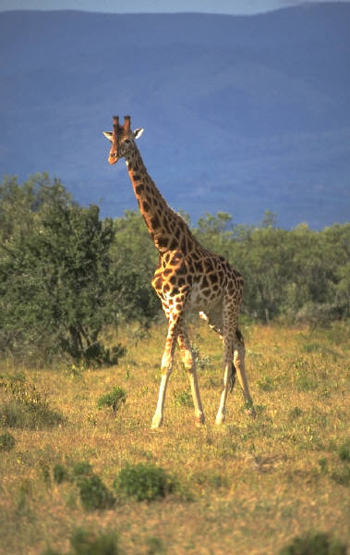Mount Kenya, Safari, and Beach

15 days/14 nights, Nairobi to Mombasa

Tour Highlights

* **Mount Kenya**: A 5-day trek to ascend Point Lenana (4985m) on Africa’s second highest mountain.
* **Samburu National Park**: Game viewing in one of East Africa’s wildest and least-visited game parks.
* **Lake Nakuru National Park**: Big game viewing in search of white rhino, lions, leopards, and flamingos.
* **Maasai Mara Reserve**: Extensive game viewing amid classic African landscapes.
* **Mombasa**: Luxury and relaxation beside the warm tropical waters of the Indian Ocean.

Tour Summary

This fabulous tour showcases the major natural wonders of East Africa: Mount Kenya, impressive big game, and the spectacular coast of the Indian Ocean. Our journey begins in Nairobi, from where we head to our first campsite at the foot of towering Mount Kenya, Africa’s second highest mountain. Mount Kenya has long been revered by the local Kikuyu people, who believe that its frozen summit is home to the god Ghai. Over the course of a 5-day trek, we ascend the imposing slopes of this sacred giant across a demanding terrain of ice, snow, and moraine glaciers. Our route takes us high above the African plains, staying in basic huts as we make our way toward the summit of Point Lenana (4985m), from where we watch the sun rise over the endless Kenyan landscape far below us.

After descending Mount Kenya, we embark on a classic African safari, encountering spectacular wildlife as we traverse some of the finest game parks in Africa. We travel first to the hidden gem of Samburu National Park, where the Ewaso Ngiro River has created an abundant oasis for wildlife amid the semi-desert landscape of the Northern Frontier. Next we visit the shallow soda lakes in the Kenyan Rift Valley, Lake Elementeita and Lake Nakuru, where the shallow pockets of rich, highly alkaline water are a haven for a staggering diversity of game and birdlife, including the magnificent spectacle of thousands of flamingoes. Finally, we journey to the Maasai Mara Reserve, one of Africa’s most incredible wilderness areas, where we hope to see evidence of the “Big 5”—elephant, lion, leopard, buffalo, and rhino—as well as herds of wildebeest, zebra, and gazelle that roam in large numbers across the grasslands. The Maasai Mara is Africa at its most captivating—endless savannahs, vast herds of migratory animals, and the grim glory of life’s constant struggle for survival.

The final leg of our journey takes us by first-class train to Mombasa, where we stay in beachside cottages and relax amid the tropical surroundings, white sand beaches, coral reefs, and warm waters of the Indian Ocean. The remarkable extremes of this spectacular journey encompass the very best of Kenya.

Planning Your Trip

Climate

Climatic conditions in Kenya vary from the tropical humidity of the coast, through the dry heat of the hinterland and northern plains, to the cool air of the plateau and mountains. Although Kenya straddles the equator, Mt. Kenya is perpetually snow-capped. The coastal temperature averages 27°C, and the temperature decreases by slightly less than 2°C with each 300 meter increase in altitude. The capital, Nairobi, at 1,675 meters, has a mean annual temperature of 19°C, and the arid plains vary from 21°C to 27°C. Seasonal variations are distinguished by duration of rainfall rather than changes of temperature; most regions of the country have two rainy seasons, the long rains falling between April and June, and the short rains between October and December. The weather on Mount Kenya can be dangerously unpredictable, so be prepared for cold, wet, windy weather at any time of year. Temperatures can drop as low as -10°C at night. Mid January to late February, August, and September are generally the best times of the year to trek.

Visa and Vaccination Requirements

All incoming visitors to Kenya require an entry visa, except citizens of other East African nations. To arrange a visa, contact the Kenyan Embassy or a consulate in your home country prior to travelling to Kenya.

No vaccinations are required for travel to Kenya, but we recommend protection against malaria, typhoid, tetanus, diphtheria, polio, and hepatitis A. Consult your travel clinic or healthcare provider for advice.

Visa and vaccination requirements are subject to change and should be confirmed prior to departure.

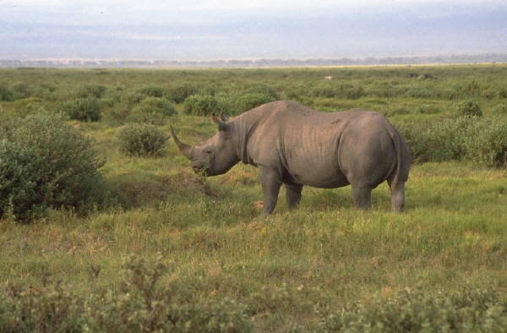

What to Bring

Luggage

* One main piece of baggage plus a day pack. Total maximum allowance is 33lbs/15kgs, due to weight restrictions on our truck. The limit does not include camera equipment.

Clothing and Footwear

* Walking boots that are well broken in and comfortable.
* Gaiters for keeping mud, snow, and debris out of your boots.
* Sneakers or sandals for relaxing during the evening.
* Socks, including liner socks to be worn under thicker socks.
* A down jacket, a fleece or heavy sweater, and a good quality wind and waterproof jacket.
* Waterproof pants, light-weight long pants, and shorts.
* Thermal underwear.
* Waterproof gloves, a warm scarf, and a warm hat.
* Lightweight comfortable clothing for the safari, but avoid bright colors for game viewing.
* Swimwear.

Equipment

* A four-season sleeping bag and a sleeping mat, such as a Thermarest.
* Head lamp and extra batteries.
* Trekking poles.
* Water bottle or Camelbak hydration system.
* Sunhat, sun screen, lip salve, and good quality sunglasses.
* Binoculars for game viewing.
* Toiletries such as toothbrush, toothpaste, soap, small towel, nail brush, and wet wipes.
* Personal first aid kit that includes blister care products, band aids, and other essentials.